**NAME**

**COLLEGE NAME**

**Abstract**

Data analysis and statistical tools have been applied for a long time over the years and from the ages and times of the mediaval to the current advance and modified technologies and tools. With this kind of adabcbednts, develoers, research and development teams together with engineers have gone ahead to develop tools, and algosthms to help solve some of the statsitcstical problems in today sindurtry. Some of these tools include SATA, STRATA, MATLAB and R. There are differbnt modukes and packages athat have also been built inside these applivations that support the development and mainatennace of such tools and applications have enabled stsudenfo fo data sceine and even eprofessional engineers to rapidly brign out of the box the abilitie and capabilities of strong data understanding and unterepatetation. Pyhthn as a programming lanagues has a set of very powerful tools and packgaes that to date are still applied to help users make the best programs and explore the capabilities underlying in data science, machine learning and precitive algosthms. Almost all sectors of the industry needto amek sense of the kind of data and information that they are produing, the sectors range from Finance, Banking, Health and Educational sector. With the introruction of big data as part of the data science industry, organizations are shifing more focus into coming up a more robust and technical means of analyssina and amking sendse of the data that is currently consumed and used.

**Keywords:** Big data,Empirical, Predictive, Linearity, Skew

**Introduction**

One of the secotors that relies on constant communication in oreder to make sense from its information system is the Finance sectors. This may be alarfelu attaributes to the risky nature in which this undstry operates, it deals witn money so loses and profits must be kept in check at all times. Seqeunially, R as a powerful tool and pakcgae has been sepcfivally developed to help users get a aquick summary from their data, expoore positiosn and morevore make prredcitions. Prior to making any specifc forscts usin the tool, lets discus below some of the models and and clssictaions that can be employed on the tool to help achive the required objectives and siginificanes:

**Random Forest**

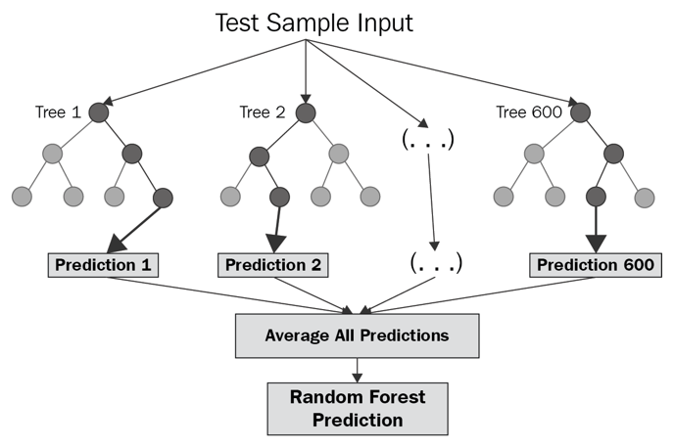

Figure 1 Random forest illustration in R

This model is most effective in machine learning. The model works for both data classification and and prediction. Usually the reoot coseu of the pbelm is identified and then the problem is solved based on the classification of nodes also knion as a bag. The higher node is also know as the parent and the node that is passed dwon to it becomes the child node. The model is higlky accuate in predicting data where classification is a major issues.

**Linear regression**

Is efficient in measuring the degree or extent to which the object in question are closely related to each other. Usullay the statndrd point of measurement being the 1 refernce upn which values that are nevegarive sked will be considered as non- linear to thecentegref of refences. On the hand, values closert to the1 are considerdc as relating. Sppose wed draw a linear graph along the axis, the staright line graph/ line of best fit will show cnetartion s around the same line.

**KNN MODEL**

The KNN model measure the closeness of classifications among each other, the model tries to predict the next closer classification class on the series.

**Dataset description and problem statement**

The dataset description given here is the dataset obtained from the S&P 500 market dataset of over years of 2001 to 2005, the values represent the past 5 revenues and the projected direct sales in the incoming months

**Objectives and aims**

* To determine the linear regression based on this dataset
* To determine the KNN statics based on this dataset
* To determine the random distribution of this dataset

Loading the SMARKET dataset;

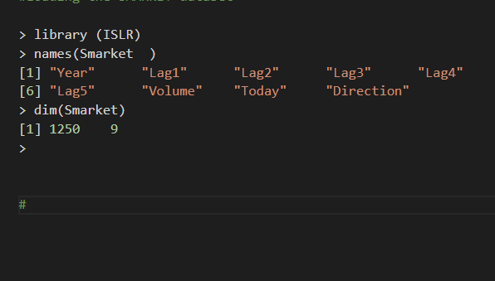

summary (Smarket)

      Year           Lag1                Lag2

 Min.   :2001   Min.   :-4.922000   Min.   :-4.922000

 1st Qu.:2002   1st Qu.:-0.639500   1st Qu.:-0.639500

 Median :2003   Median : 0.039000   Median : 0.039000

 Mean   :2003   Mean   : 0.003834   Mean   : 0.003919

 3rd Qu.:2004   3rd Qu.: 0.596750   3rd Qu.: 0.596750

 Max.   :2005   Max.   : 5.733000   Max.   : 5.733000

      Lag3                Lag4                Lag5

 Min.   :-4.922000   Min.   :-4.922000   Min.   :-4.92200

 1st Qu.:-0.640000   1st Qu.:-0.640000   1st Qu.:-0.64000

 Median : 0.038500   Median : 0.038500   Median : 0.03850

 Mean   : 0.001716   Mean   : 0.001636   Mean   : 0.00561

 3rd Qu.: 0.596750   3rd Qu.: 0.596750   3rd Qu.: 0.59700

 Max.   : 5.733000   Max.   : 5.733000   Max.   : 5.73300

     Volume           Today           Direction

 Min.   :0.3561   Min.   :-4.922000   Down:602

 1st Qu.:1.2574   1st Qu.:-0.639500   Up  :648

 Median :1.4229   Median : 0.038500

 Mean   :1.4783   Mean   : 0.003138

 3rd Qu.:1.6417   3rd Qu.: 0.596750

 Max.   :3.1525   Max.   : 5.733000

#Getting the lags  of from the dataset

> head(Smarket)

: Year   Lag1   Lag2   Lag3   Lag4   Lag5 Volume  Today Direction

1 2001  0.381 -0.192 -2.624 -1.055  5.010 1.1913  0.959        Up

2 2001  0.959  0.381 -0.192 -2.624 -1.055 1.2965  1.032        Up

3 2001  1.032  0.959  0.381 -0.192 -2.624 1.4112 -0.623      Down

4 2001 -0.623  1.032  0.959  0.381 -0.192 1.2760  0.614        Up

5 2001  0.614 -0.623  1.032  0.959  0.381 1.2057  0.213        Up

6 2001  0.213  0.614 -0.623  1.032  0.959 1.3491  1.392        Up

>

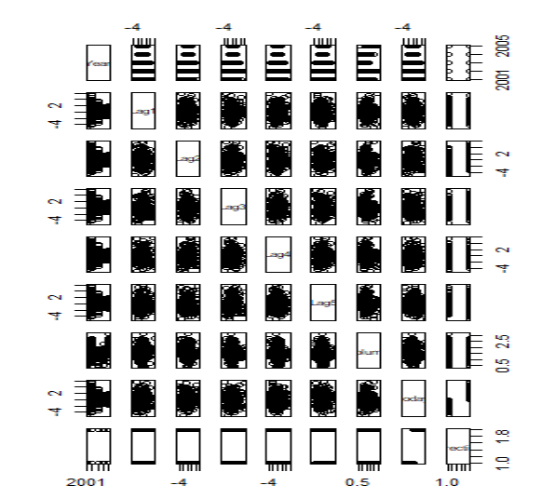

**Getting the correlation matrix**

> cor(Smarket[,-9])

             Year         Lag1         Lag2         Lag3         Lag4         Lag5

Year   1.00000000  0.029699649  0.030596422  0.033194581  0.035688718  0.029787995

Lag1   0.02969965  1.000000000 -0.026294328 -0.010803402 -0.002985911 -0.005674606

Lag2   0.03059642 -0.026294328  1.000000000 -0.025896670 -0.010853533 -0.003557949

Lag3   0.03319458 -0.010803402 -0.025896670  1.000000000 -0.024051036 -0.018808338

Lag4   0.03568872 -0.002985911 -0.010853533 -0.024051036  1.000000000 -0.027083641

Lag5   0.02978799 -0.005674606 -0.003557949 -0.018808338 -0.027083641  1.000000000

Volume 0.53900647  0.040909908 -0.043383215 -0.041823686 -0.048414246 -0.022002315

Today  0.03009523 -0.026155045 -0.010250033 -0.002447647 -0.006899527 -0.034860083

            Volume        Today

Year    0.53900647  0.030095229

Lag1    0.04090991 -0.026155045

Lag2   -0.04338321 -0.010250033

Lag3   -0.04182369 -0.002447647

Lag4   -0.04841425 -0.006899527

Lag5   -0.02200231 -0.034860083

Volume  1.00000000  0.014591823

Today   0.01459182  1.000000000

>

Logistic regression

> glm.fits=glm(Direction∼Lag1+Lag2+Lag3+Lag4+Lag5+Volume , data=Smarket ,family =binomial)

> summary(glm.fits)

Call:

glm(formula = Direction ~ Lag1 + Lag2 + Lag3 + Lag4 + Lag5 +

    Volume, family = binomial, data = Smarket)

Deviance Residuals:

   Min      1Q  Median      3Q     Max

-1.446  -1.203   1.065   1.145   1.326

Coefficients:

             Estimate Std. Error z value Pr(>|z|)

(Intercept) -0.126000   0.240736  -0.523    0.601

Lag1        -0.073074   0.050167  -1.457    0.145

Lag2        -0.042301   0.050086  -0.845    0.398

Lag3         0.011085   0.049939   0.222    0.824

Lag4         0.009359   0.049974   0.187    0.851

Lag5         0.010313   0.049511   0.208    0.835

Volume       0.135441   0.158360   0.855    0.392

(Dispersion parameter for binomial family taken to be 1)

    Null deviance: 1731.2  on 1249  degrees of freedom

Residual deviance: 1727.6  on 1243  degrees of freedom

AIC: 1741.6

Number of Fisher Scoring iterations: 3

>

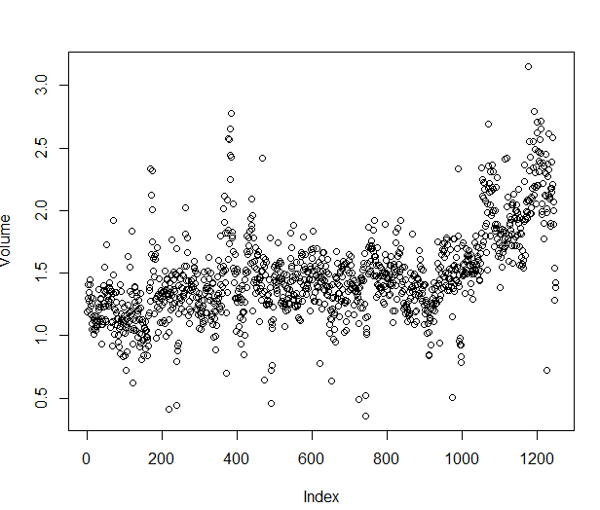

Correlation model

#Corellation model

> coef(glm.fits)

 (Intercept)         Lag1         Lag2         Lag3         Lag4         Lag5

-0.126000257 -0.073073746 -0.042301344  0.011085108  0.009358938  0.010313068

      Volume

 0.135440659

>